
Computing Newsletter
Autumn Term 2

Welcome to this half term’s issue of our Computing newsletter. This half term the children are using a range of programs and devices to create some fun projects

A reminder of how we teach computing at Annie Lennard

Computing is a vital part of the curriculum and allows prepare the children to help them navigate and be safe in an ever developing and growing technological world. There are three aspects of computing. Across the year, the children explore all three aspects of computing multiple times to ensure they are able to develop the range of skills and knowledge needed.
The three aspects are;

Computer Science - How computers and computer systems work and how they are designed and programmed.
Information Technology – Using existing programs to develop products and solutions using existing programs in a purposeful way. This can include making podcasts, taking photos or creating digital art.
Digital Literacy – Developing the skills, knowledge and understanding needed in order to participate fully and safely in an increasingly digital world

We follow the Teach Computing scheme of work which allows for a progressive curriculum for the children and is approved by the Department for Education.
The children work on a range of technologies including Chromebooks, iPads, Laptops, Crumbles and Micro-bits.

Work from last half term
Here is some amazing work from Year 1 where they have been developing their mouse skills to create images of themselves.
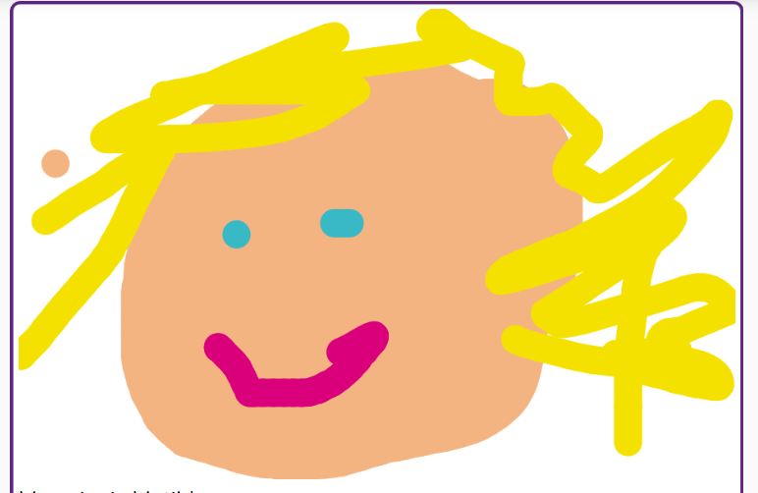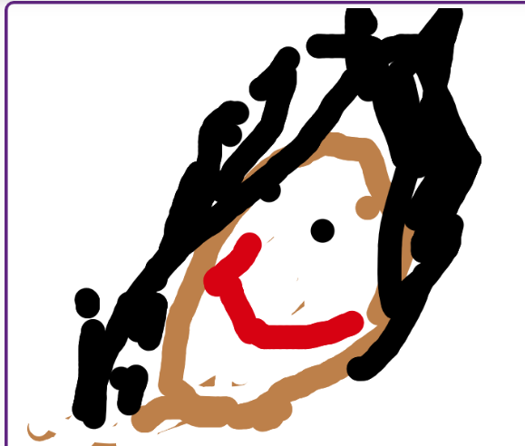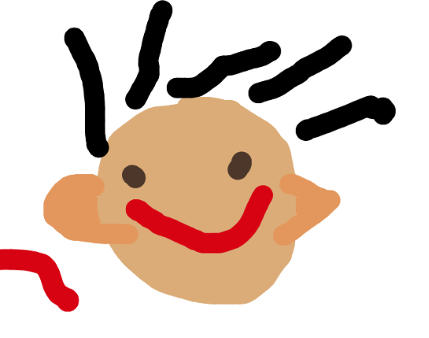

Year 3 have been looking at inputs, processes and outputs within their network topics. They have also been on a scavenger hunt to help them find different parts of our school network.
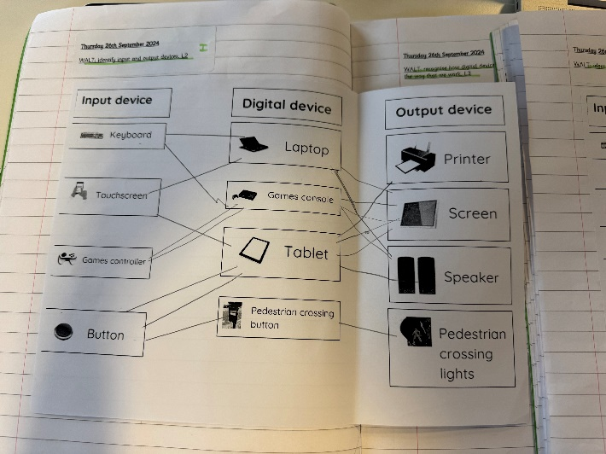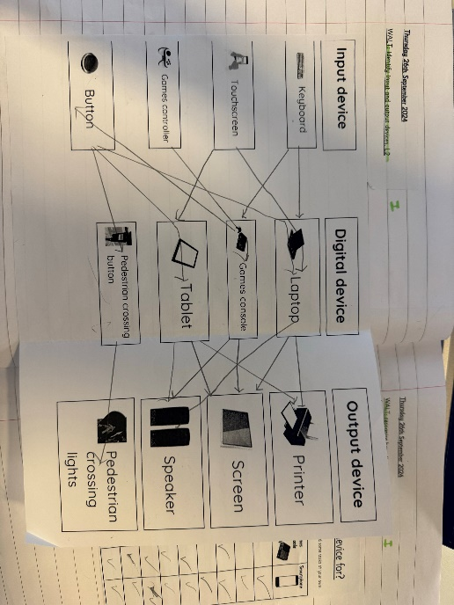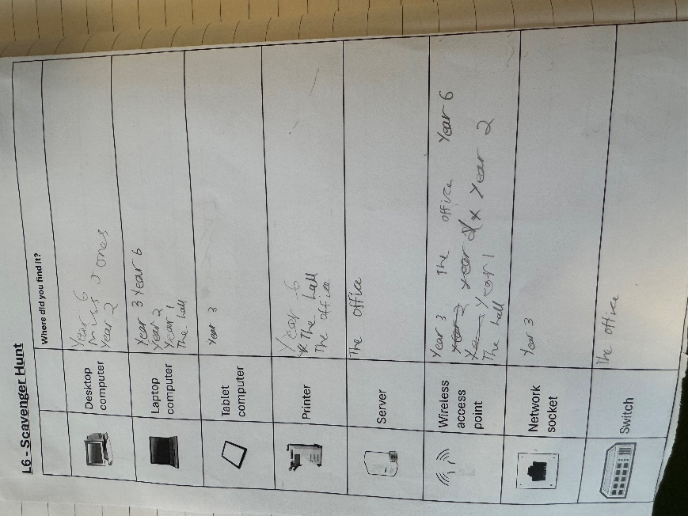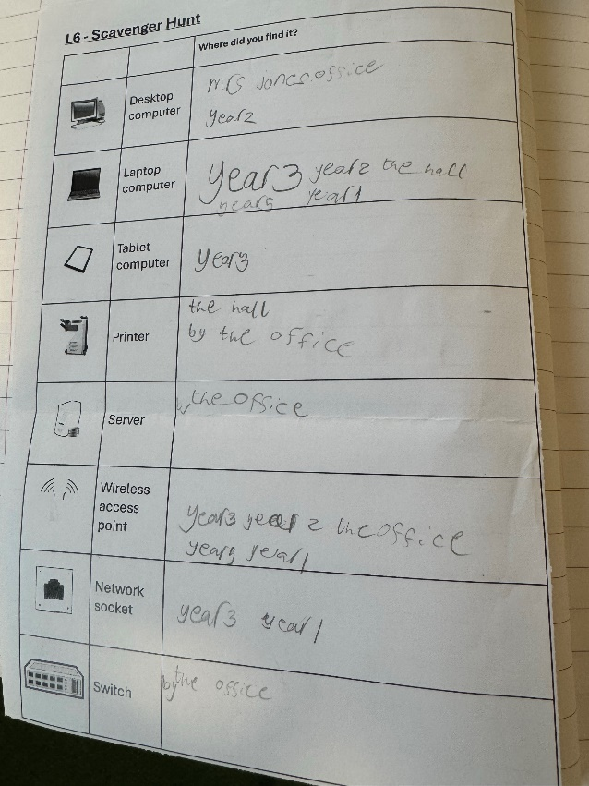

Online Safety

Online Safety is a huge part of school life and is consistently and constantly covered in computing lessons.

This half term’s focus will be based upon Online Bullying and Online Reputation
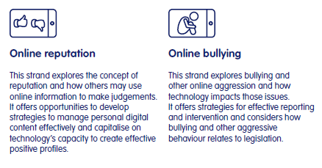
We are also doing a whole class focus linked to anti-bullying week during the second week of this half term.

Online safety is recorded in the children’s books and as part of the whole class book that moves with them as they go through school.
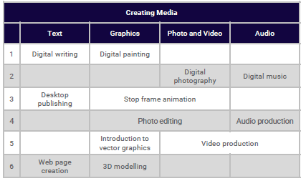
Autumn 2 – Creating Media

The Creating Media strand hosts a wide range of different media types, and therefore different skills. To support progression, this can be best categorised into four different key areas: text, graphics (the use of pictures and text), photo and video, and audio.

Year 1 – Digital Painting
The children will develop their understanding of a range of tools used for digital painting. They then use these tools to create their own digital paintings, while gaining inspiration from a range of artists’ work. The unit concludes with the children considering their preferences when painting with and without the use of digital devices.

Year 2 – Digital Photography
The children will learn to recognise that different devices can be used to capture photographs and will gain experience capturing, editing, and improving photos. Finally, they will use this knowledge to recognise that images they see may not be real.

Year 3 – Stop Motion Animation
The children will use a range of techniques to create a stop-frame animation. They will apply those skills to create a story-based animation. This unit will conclude with the children adding other types of media to their animation, such as music and text. This unit uses the context of one of the topics that the children explore in other subjects to help engage them further.
Year 4 – Audio Production
The children will identify the input device (microphone) and output devices (speaker or headphones) required to work with sound digitally. The children will discuss the ownership of digital audio and the copyright implications of duplicating the work of others. In order to record audio themselves, the children will use Audacity to produce a podcast, which will include editing their work, adding multiple tracks, and opening and saving the audio files. Finally, the children will evaluate their work and give feedback to their peers. This unit uses ‘school news’ as a context for the podcasts.
Year 5 – Video Production
The children will learn how to create short videos by working in pairs or groups. As they progress through this unit, they will be exposed to topic-based language and develop the skills of capturing, editing, and manipulating video. The children are guided with step-by-step support to take their idea from conception to completion. At the conclusion of the unit, learners have the opportunity to reflect on and assess their progress in creating a video.
Year 6 – Webpage Creation
In this unit, the children will be introduced to creating websites for a chosen purpose. They identify what makes a good web page and use this information to design and evaluate their own website using Google Sites. Throughout the process, the children pay specific attention to copyright and fair use of media, the aesthetics of the site, and navigation paths.

